Part 1: The effect of treatment on different *Dalechampia* species

By: Eila Forsman, BIOS14, January 2023.

# Introduction

Data was collected from an experiment in which *Dalechampia* plants from two populations each of two species (“S” and “L”) were exposed to either dry or wet experimental conditions in a greenhouse. Blossom traits were measured on blossoms in early bisexual condition. *Dalechampia sp*. grows in the Neotropical region (Armbruster, 1985) which leads me to believe that it prefers wetter environments. I will therefore investigate whether the wet or dry treatment affects blossom size and whether this effect differs between the different *Dalechampia* species.

# Method

Histograms were used to determine normal distribution on upper and lower bract width. Linear regression was used to check for correlation between lower and upper bract width, which was then used to infer that upper bract width could be used as an estimate for the entire blossom size. Comparison of the effect of wet or dry treatment on upper bract width for the two species was performed with a Two-way ANOVA with treatment and species as predictors and upper bract width as the response variable (https://github.com/eilaforsman/BIOS14.git).

# Results

Lower and upper bract width were strongly correlated where 1mm change in lower bract width led to a 0.91mm change in upper bract width (R=0.91, p < 0.001, fig 1). There were 177 *Dalechampia* plants subjected to the dry treatment and 187 plants in the wet treatment. The blossoms grew 22.4% bigger in the wet treatment than in the dry treatment (mean upper bract width 21.7 mm and 16.8 mm respectively, F2,360 = 9128,14, p < 0.001, fig 2, tab 1). *Dalechampia* of the “L” species grew 9% bigger than the “S” species (mean upper bract width 20,1 mm and 18.4 mm respectively, F1,360 = 39.11, p < 0.001, fig 2, tab 1). The difference in blossom size between treatments was slightly larger for the “L” species than for the “S” species (24.1% reduction vs 20.5% reduction respectively, fig 2, tab 2).

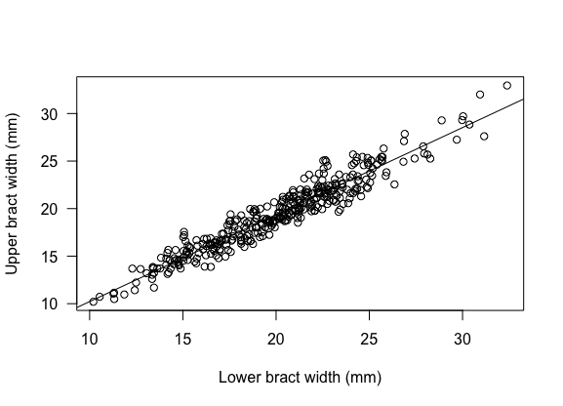

Figure 1: Upper and lower bract width were strongly correlated, R=0.91. Line shows regression line estimated from a linear regression model.

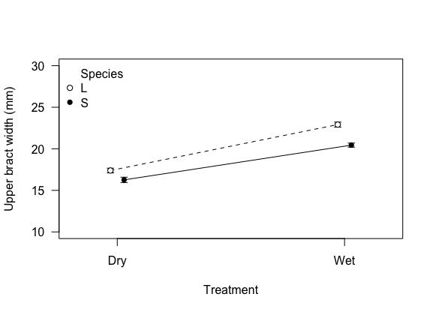

Figure 2: Change in upper bract width (mm) from dry or wet treatment on the two *Dalechampia* species “S” and “L”.

Table 1: Mean upper bract width (mm) $±$ standard error and test value (F) with significance level (p) from Two-way ANOVA comparing upper bract width between treatment and species and their interaction.

|  |  |  |  |  |
| --- | --- | --- | --- | --- |
|  | Mean $±$ SE |  | F | p |
| Dry | 16.8 $±$ 0.30 | Treatment | 9128.14 | <0.001 |
| Wet | 21.7 $±$ 0.27 | Species | 39.11 | <0.001 |
| “L” | 20.1 $±$ 0.29 | Interaction | 5.30 | 0.022 |
| “S” | 18.4 $±$ 0.28 |  |  |  |

Table 2: Mean upper bract width (mm) $±$ standard error for each treatment and species.

|  |  |  |
| --- | --- | --- |
|  | Mean $±$ SE | |
|  | **Dry** | **Wet** |
| “L” | 17.39 $±$ 0.28 | 22.91 $±$ 0.30 |
| “S” | 16.26 $±$ 0.32 | 20.44 $±$ 0.24 |

# Discussion and Conclusion

When *Dalechampia* were subjected to dry treatment the blossom size decreased dramatically for both species. There was also a slight difference in blossom size between the two species “S” and “L” regardless of treatment, where “L” was bigger than “S”. The interaction of both treatment and species affected blossom size where “S” species in the dry treatment were smallest but the dry treatment caused a larger decrease in blossom size for the “L” species. This suggests that the “L” species is more sensitive to drought than the “S” species.

# References

Armbruster, W. S. (1985). Patterns of character divergence and the evolution of reproductive ecotypes of *Dalechampia scandens* (Euphorbiaceae). *Evolution,* 39, 733–752.

Part 2: Differences in mass between female and male mountain goats

By: Eila Forsman, BIOS14, January 2023.

# Introduction

The following data analyses the mass of mountain goats and possible differences in mass between male and female goats. Male individuals in the animal kingdom are generally heavier than females, therefore I hypothesize that the male mountain goats will be heavier.

# Method

A histogram of data distribution for mass was used to determine that the data was normally distributed and parametric tests could be used in the analysis. Difference in mass between sexes was analyzed with an ANOVA where sex was used as the predictor and mass as the response variable (https://github.com/eilaforsman/BIOS14.git).

# Result

Mass measurements were taken on 1955 female goats and 2439 male goats (tab 1). Comparison showed that male goats were 13.1% heavier than female goats (mean mass 23.7 $±$ 0.10 and 20.6 $±$ 0.12 respectively, fig 1, tab 1, F1,4392 = 395.63, p <0.001, Appendix: tab 1).

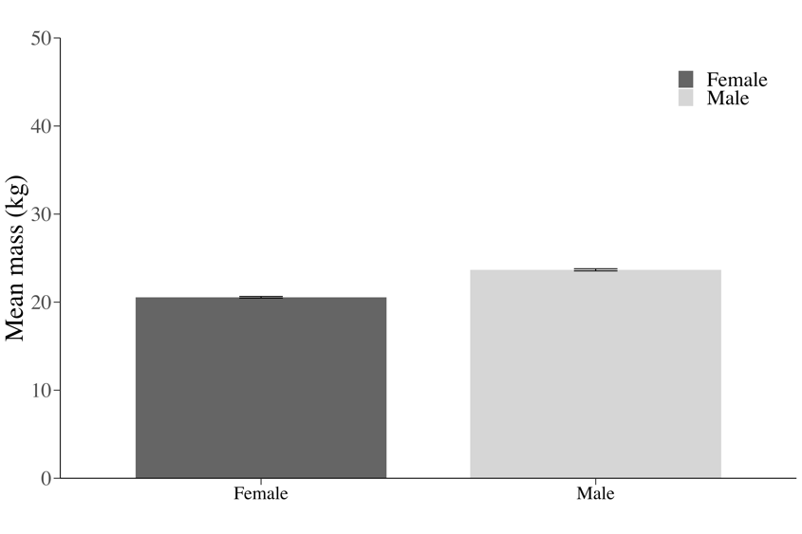

Figure 1: Mean mass (kg) of male and female mountain goats. Error bars show +/- 1 SE.

Table 1: Mean mass (kg) +/- 1 standard error of female and male mountain goats and how many there were of each sex along with

|  |  |  |
| --- | --- | --- |
|  | Mean $±$ SE | N |
| Female | 20.6 $±$ 0.12 | 1955 |
| Male | 23.7 $±$ 0.10 | 2439 |

# Conclusion

The male mountain goats were heavier than the female mountain goats, as hypothesized. This could confidently be concluded since the standard error of the estimates mean mass for each sex is low. Even with +/- 1 SE the estimated mean masses do not overlap.

# Appendix

Table 1: Test value (F) and significance level (p) from ANOVA comparing difference in mass between the sexes. Index on F shows degree of freedom for groups (1) and for number of datapoints (4392).

|  |  |  |
| --- | --- | --- |
|  | F1,4392 | p |
| Sex | 395.63 | < 0.001 |
|  |  |  |